Application Layer (HTTP): Sends the request (GET ) and receives the response (200 OK) with headers like Host, User-Agent, Content-Type, etc.
Transport Layer (TCP): Ensures reliable delivery using port 80, handling segmentation and acknowledgments.
Network Layer (IP): Routes packets between the client and server using IP addresses.
Data Link Layer (Ethernet): Uses MAC addresses to deliver the frame within the local network.
Physical Layer: Transfers the raw bits over the network medium.

Request

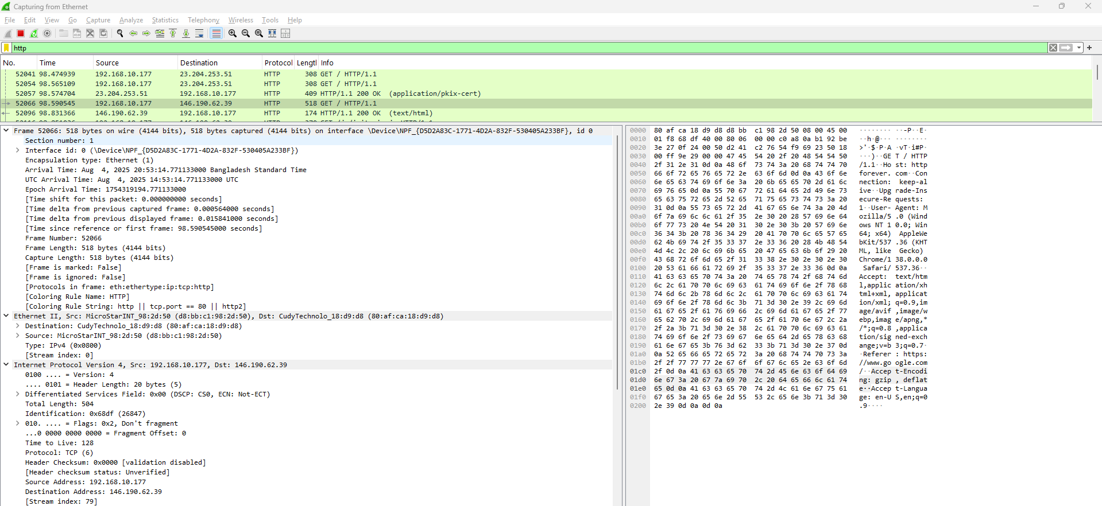
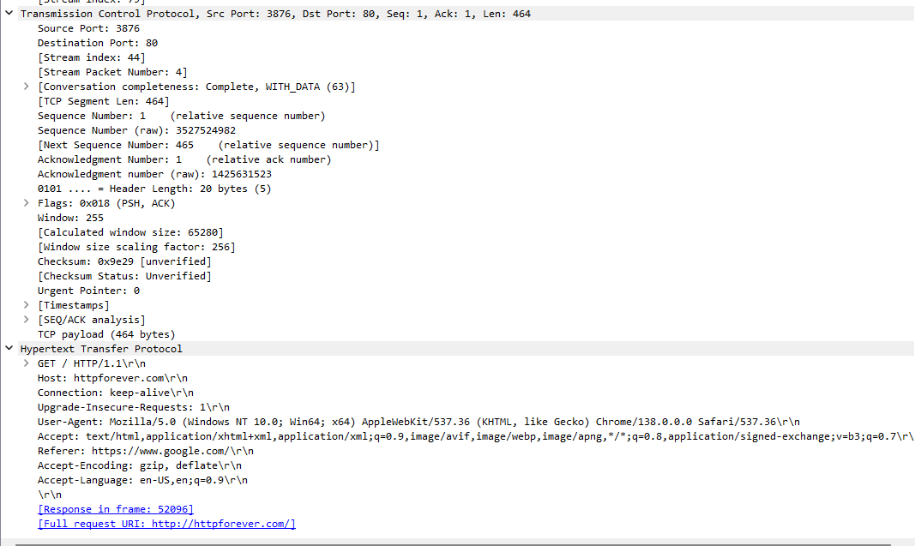

Response
